**Exercise 1: What is the total number of observations in this dataset?**

**Answer:**

Total number of observations in dataset is 63.

**Script:**



**Console:**

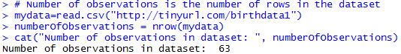

**Exercise 2: What range years are included in this dataset?**

**Answer:**

The years in the dataset range from 1940 to 2002.

**Script:**



**Console:**



**Exercise 3: What command would you use to extract just the counts of girls born?**

(a) mydata$boys

(b) mydata$girls

(c) girls

(d) mydata[girls]

(e) $girls

**Answer:**

mydata$girls

**Script:**



**Console:**

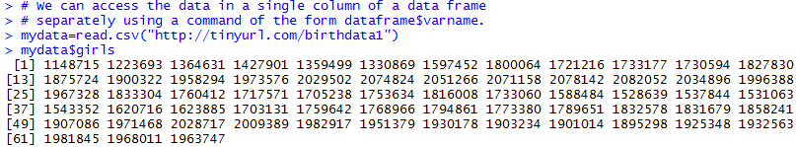

**Exercise 4: What is the mean (average) of the girl births?**

**Answer:**

The mean(average) of the girl births is

**Script:**



**Console:**

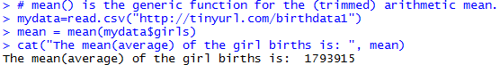

**Exercise 5: Is there an apparent trend in the number of girls born over the years? How would you describe it? Answer with just a few sentences.**

**Answer:**

Yes, there is an apparent trend in the number of girls born over the years. The number of girls born each year progressively increases till it reaches a ceiling value IN 1960 and then declines till it hits a local minima value between 1970 and 1980.

**Script:**



**Plot:**

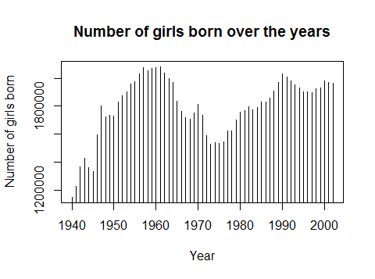

**Exercise 6: Create a similar time plot for the boy data using connected lines.**

**Script:**

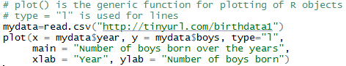

**Plot:**

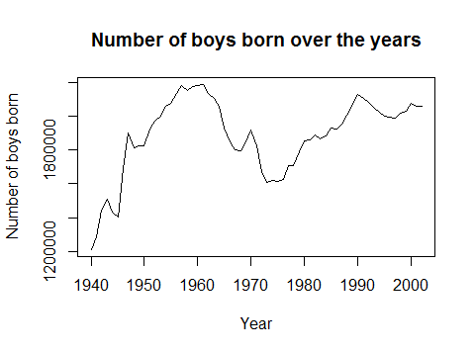

**Exercise 7: What is the minimum of the total number of births? Which year did this happen?**

**Answer:**

Minimum of the total births is 2360399 and this happened in 1940

**Script:**

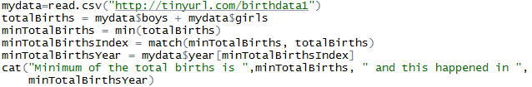

**Console:**

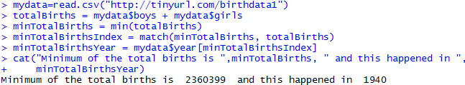

**Exercise 8: What is the maximum of the total number of births? Which year did this happen?**

**Answer:**

Maximum of the total births is 4268326 and this happened in 1961

**Script:**

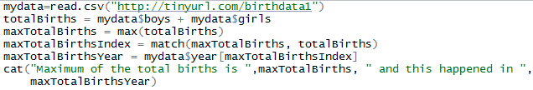

**Console:**

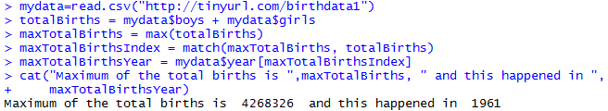

**Exercise 9: What are the max and min of the proportion of boys born over time?**

**Answer:**

The max proportion of boys over time is 0.5142562 and the min is 0.5111665

**Script:**

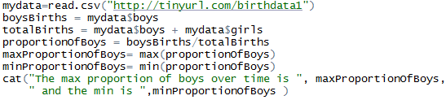

**Console:**

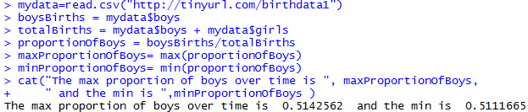

**Exercise 10: Make a plot of the proportion of boys over time.**

**Script:**

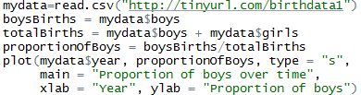

**Plot:**

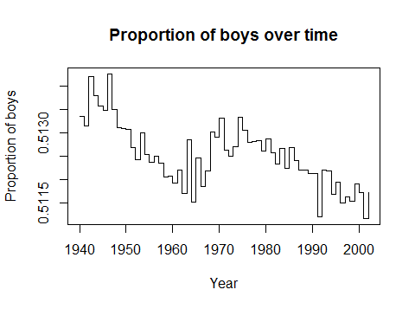

**Exercise 11: Briefly comment on the plot of the proportion of boys over time.**

**Answer:**

The proportion of boys over time ranges from 0.5111665 to 0.5142562. While the proportion does change over time, it always exceeds the proportion of girls over time.

**Script:**



**Console:**

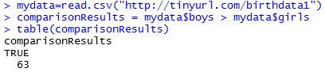

**Exercise 12: Which statement is true?**

**(a) Every year there are more girls born than boys.**

**(b) Every year there are more boys born than girls.**

**(c) Half of the years there are more boys born, and the other half more girls born.**

**Answer:**

(b) Every year there are more boys born than girls.

**Script:**



**Console:**

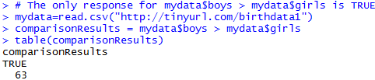

**Exercise 13: Make a plot that displays the boy-to-girl ratio for every year in the data set.**

**What do you see?**

**(a) There appears to be no trend in the boy-to-girl ratio from 1940 to 2002.**

**(b) There is initially an increase in boy-to-girl ratio, which peaks around 1960. After 1960 there is a decrease in the boy-to-girl ratio, but the number begins to increase in the mid 1970s.**

**(c) There is initially a decrease in the boy-to-girl ratio, and then an increase between 1960 and 1970, followed by a decrease.**

**(d) The boy-to-girl ratio has increased over time.**

**(e) There is an initial decrease in the boy-to-girl ratio born but this number appears to level around 1960 and remain constant since then.**

**Answer:**

(c) There is initially a decrease in the boy-to-girl ratio, and then an increase between 1960 and 1970, followed by a decrease.

**Script:**

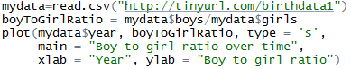

**Plot:**

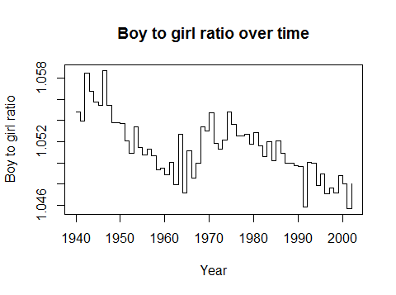

**Exercise 14: Calculate absolute differences between number of boys and girls born in each year and determine which year out of the present data had the biggest absolute difference in the number of girls and number of boys born.**

**Answer:**

Year that had the biggest absolute difference in the number of girls and number of boys born: 1963

**Script:**

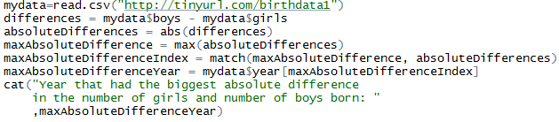

**Console:**

